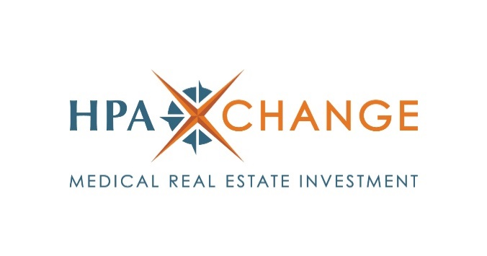

**FOR IMMEDIATE RELEASE**

**Contact:**

Julie Leber

Spotlight Marketing Communications

949.427.1391

[julie@spotlightmarcom.com](mailto:julie@spotlightmarcom.com)

**HPA Exchange Launches $15.4 Million DST Offering of a Modern Micro-Hospital Leased to an Investment-Grade Tenant**

PHOENIX (Sept. XX, 2024) – HPA Exchange LLC, a healthcare real estate investment sponsor created by the executive team of Healthcare Property Advisors, a vertically integrated healthcare real estate owner and operator, announced today the launch of HPA Dignity Health Arizona DST. Seeking to raise $15.4 million in equity from accredited investors, the Delaware statutory trust offering consists of a full-service micro-hospital in Phoenix that is 100% leased on an absolute triple net basis to Dignity Health.

“We are incredibly excited to introduce HPA Dignity Health Arizona DST to broker-dealers, registered investment advisory firms, financial advisors and their accredited investor clients,” said Robert Lee, co-president and chief investment officer of HPA Exchange. “This offering is a prime example of our commitment to bringing institutional-quality, mission-critical healthcare real estate investment opportunities to the alternative investment community. Backed by a strong tenant and our team's extensive knowledge and experience, we are confident in this offering's long-term investment fundamentals.”

Located at 7171 S. 51st Drive, the 3.92-acre property was built-to-suit and completed in 2014 for Arizona General, a wholly owned subsidiary of Dignity Health. The acute care micro-hospital is in Phoenix’s Laveen Village, approximately eight miles southwest of downtown. Including 38,900 rentable square feet, the hospital includes: a 24/7 emergency department; 16 patient beds; 10 emergency room beds; two advanced operating suites for surgical procedures; a full onsite laboratory; a full radiology suite with 64-slide CT scan, X-ray and ultrasound capabilities; a pharmacy; and a cafeteria. The hospital’s lease is guaranteed by Dignity Health.

A multi-state nonprofit network, Dignity Health is a part of CommonSpirit Health, a nonprofit health system with more than 2,200 care sites in 24 states, 35,000 providers and 45,000 nurses. The health system has a Moody’s credit rating of A3 as of March 2024 and reported revenues of $34.6 billion in its fiscal year 2023. Dignity Health has more than 10,000 physicians, 400 care centers, and a reported $10.8 billion 2023 annual revenue. As a part of CommonSpirit Health, Dignity Health is the largest Catholic health system in the nation, according to rankings from Becker’s Hospital Review.

“This micro-hospital, leased to a leading healthcare system like Dignity Health, exemplifies the type of resilient, high-quality properties we seek to offer through HPA Exchange,” said Thuy Turner, co-president and chief operating officer. “Not only does this facility provide robust healthcare access for the community, but we believe it will also resonate with investors seeking access healthcare investment opportunities for Section 1031 exchanges and cash investments through the Delaware statutory trust structure.”

According to Jones Lang LaSalle’s report, Medical Outpatient Building Perspective, released in April, medical outpatient buildings have seen relentless demand and remain one of the most resilient commercial real estate property types.

Healthcare Property Advisors is a vertically integrated institutional real estate fund manager, owner, operator and developer. HPA launched [HPA Exchange LLC](http://www.hpaxchange.com) in 2024 to bring institutional quality medical real estate investments to accredited investors via the broker-dealer and registered investment advisory firm markets that cater to investors utilizing 1031 exchanges for their investment portfolios and estate planning purposes.

Section 1031 of the Internal Revenue Code allows for the deferral of capital gains taxes that may come from the sale of a business or investment property. To participate, a seller reinvests the proceeds of their sale into a replacement property that is of equal or greater value, also known as a like-kind exchange. The replacement property must be identified within 45 days, and the exchange completed within 180 days in order to defer up to 100% of any capital gain that resulted from the original sale. The gains are deferred, not forgiven, and will be taxed once the replacement property is sold or exchanged in another like-kind exchange.

HPA Exchange seeks to offer institutional-grade core and core-plus institutional-quality properties that are operated by best-in-class healthcare systems, established physician groups and life science groups for outpatient purpose-built facilities. The investment firm is led by a seasoned management team with an average of more than 20 years each of experience in healthcare real estate.

**About HPA Exchange LLC**

HPA Exchange LLC is a new business platform created by the executive team of Healthcare Property Advisors, a vertically integrated healthcare real estate owner, investor, and operator. The vertical integration of the firm allows HPA to leverage the relationships with a large network of healthcare systems, and provide active asset management, investment and development of medical office buildings and outpatient facilities. Healthcare Property Advisors’ executive team has acquired or advised on the investment of more than $1 billion in healthcare-related properties since 2014. Headquartered in Brea, California, HPA Exchange is a real estate investment sponsor that provides private placement offerings focused on medical properties anchored by credit-tenant healthcare systems, physician groups, life science groups and other outpatient facilities. For more information, visit [www.hpaxchange.com](http://www.hpaxchange.com).

HPA Exchange, LLC offers securities through American Alternative Capital, LLC, member FINRA/SIPC. Only available in states where AAC is registered. AAC is independent of HPA Exchange, LLC and Healthcare Property Advisors, LLC. This communication is provided for informational purposes only. Additional information is available upon request. Historical data does not guarantee future results. Delaware Statutory Trust and real estate security investments may be speculative, illiquid, and carry a high degree of risk – including the potential loss of the entire investment. The foregoing is not a complete list of all the risks related to this investment strategy. Investors should review the “Risk Factors” section in the private placement memorandum. “Investment-grade” refers to tenants whose long-term corporate debt rating is considered investment grade by Standard & Poor’s, Moody’s, and/or Fitch. An investment grade rating is a rating that indicates that a corporate bond has a relatively lower risk of default than a corporate bond with a speculative grade.

*###*